EXPT NO : 7
DATE : 03.9.2008

RC PHASE SHIFT OSCILLATOR

AIM

To design and set up an R C phase shift oscillator using BJT to obtain sinusoidal waveform of frequency of oscillation 1KHz.

COMPONENTS REQUIRED:

SL.NO | COMPONENTS | SPECIFICATION | QUANTITY
1  2  3  4  5  6  7  8 | Transistor  Resistors  Capacitor  DC power supply  CRO  Bread board  Wires  Multi meter | BC547  47kohm,10 kohm,2.2kohm,  680 ohm,  4.7k ohm  1µf  0.01 µf  22 µf  12 V | 1  1  2  1  1  1

THEORETICAL BACKGROUND:

Oscillator is basically, an amplifier with a positive feedback. It doesn’t require an input signal. In order to provide a positive feedback, the network must provide a unity loop gain, kAv = 1, where, k is a constant and Av is the voltage gain of the amplifier. The above condition is called the Barkhausen criteria.

If a common emitter amplifier is used, with a resistive collector load, there is a 180 degree phase shift between the voltages at base and collector. Feed back network between collector and base must introduce an additional 180 degree phase shift at a particular frequency. The required phase shift is the feedback from output to input obtained by using R and C components instead of the tank circuit.
Here a common emitter amplifier is followed by 3 sections of RC phase shift network, the output of the last section being returned to the input. In order to make the 3 RC sections identical, the third resistance is chosen as R-Ri where Ri is the input impedance of the circuit. The phase shift Φ,is given by each RC section
Φ=tan⁻¹(1/RCω)
If R is made zero, then Φ will become 90 degrees. But making R=0,is impractical because if R=0,then the voltage across it will become zero. Therefore in practice the value of R is adjusted such that Φ becomes 60 degrees.
By analysis it can be expressed by the equation,
f=1/2пRC√6+4Rc/R
Condition for oscillation is given by the relation h_{fe}>23+29R/Rc+4Rc/R
While selecting the transistor, care must be taken to assure that its hfe is sufficiently high .

PROCEDURE:

1.check all the components using multimeter .connect the circuit on the bread board as per the circuit diagram. Set up the amplifier part of the oscillator
2.The power supply is switched on and Vcc is supplied
3.Connect the feed back network and observe the sine wave on the CRO and measure the amplitude and frequency of it.
4.Observe the waveforms at the base and collector of the transistor simultaneously on CRO screen and notice the phase difference between them.
5.The output waveforms are plotted to scale.

DESIGN

Fr=(1/2∏RC√6+4k) , k=Rc/R , h _{f e} =23+4k+(29/k)
Let Vcc = 12V
Ic = 2 mA
Β = 200

Vrc = 40 % of Vcc = 0.4*12=4.8 V
Rc = Vrc/Ic = 4.8/(2*10^-3) = 2.2 kΩ

IeRe = V_{re}.
Re = (1.2/10^-3)/2 = 600Ω
Let Re = 680Ω
For sustained oscillations ,AB>=1,and hence h _{f e} >=4k+23+29/k
Assume k=0.5 h _{f e} >=4*0.5+23+29/k >=83

Choose BC107 where h _{f e} (min)=100

I_{b} =Ic / h _{f e} min=( 2*10 ⁻³ )/100 =20µA
Assume the current through R1=10 I_{b} and that through R2=9 I_{b} , to avoid loading the
Potential divides by the base current.
Vr2=V_{Be} + Vre = 0.6 +1.2 =1.8V

I.e., 9 IbR2=1.8V => R2=1.8/(9*20*10^-6)=110.6 kohm

Let us take R2 = 10 kΩ

Vr1 = Vcc-Vr2 = 12-1.8 = 10.2 V

10 IbR1=10.2V => R1=10.2/(10*20*10^-6)=50 kohm

Select Rf =47 kohm , k=Rc/R=>R=Rc/k =2.2*10^3 / 0.5 =4.4 kohm

Select R= 4.7 kohm
Fr=1 kHz
Fr=(1/2∏RC√6+4k) =1000

C= 0.0119µf select c=0.01µf
X _{c e} <= Re/10 <=680 /10 <= 68 ohm
R e >= 1/ (2∏Fr X _{c e}) >= 1 /(2∏ *1000*68) >= 2.34µf

Select Ce= 22 µf
Xce<=Rc/10 ,=2.2*10^3 /10<=220 ohm
Cc>=1/ (2∏Fr X _{c e}) <=1/2∏*220*10^3 >=0.723 µf

Select Cc=1 µf , we have R3+R1=R, i.e.R3+1k=4.7k => R3=3.7k

Choose R3 as 5k pot

CIRCUIT DIAGRAM
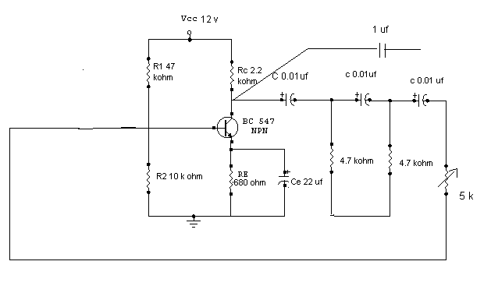

RESULT
The waveform for the RC Phase Shift Oscillator was obtained and observed.

INFERENCE

The RC Network produce a 180 degree phase shift while the amplifier network produces the initial 180 degree phase shift. As a result the final feedback is positive and in phase. The waveform for the RC Phase shift Oscillator was obtained and observed.

EXPT NO: 9
DATE: 8.09.2005

COMMON EMITTER CHARACTERISTICS

AIM:
To plot the input and output characteristics of an NPN transistor in common emitter configuration and to calculate various parameters like
- Dynamic input resistance
- Dynamic output resistances &
- Current gain (α).

THEORETICAL BACKGROUND:

The name CE is because the emitter of the transistor is common to the input and the output circuits. Input signal is applied across the base and emitter and the output is taken across the collector & the emitter. CE configurations is also called grounded emitter configuration

Transistor can be connected in a circuit in any one of the 3 different configurations, namely, common emitter, common base & common collector. Common emitter (CE) configuration is the most frequently used configuration because it provides voltage, current & power gain more than unity. The name CE is because The emitter of the transistor is common to the input and the output circuits. Input signal is applied across the base and emitter and the output is taken across the collector & the emitter. CE configurations is also called grounded emitter configuration.

Each circuit connection has specific advantages and disadvantages. It may be noted that here that regardless of the circuit connection, the emitter is always biased in the forward direction, while the collector always has a reverse bias.

In CE configuration input is applied between base and emitter and output is taken from the collector and emitter. Here, emitter of the transistor is common to both input and output circuits & hence the name.

Dynamic input resistance:
Dynamic input resistance can be calculated from the input characteristics curves. It is given by the ratio of small change in the base to emitter voltage to corresponding change in the base current, keeping collector current to emitter voltage constant.IB

ie; ri=∆ VCE /∆ IB keeping VCE constant

Dynamic output resistance:
Dynamic output resistance can be calculated from the output characteristic curves. It is given by the ratio of small change in collector to emitter voltage to corresponding change in collector current, keeping base current constant.

ro = ∆ VBE / ∆ IB keeping IB constant

Common emitter current gain ( β) :It is the ratio of the change in collector current to the corresponding change in base current, keeping the collector to emitter voltage constant.

β =∆ IB /∆ IB keeping VCE constant

Another designation for β is hfe.

Relation between β & α:
The current gain in common Base configuration α is related to
β = α /(1- α) and
α = β/(1+ β).

α is always less than unity. It is evident that as α approaches unity, value of β rises rapidly.
In almost any transistor, less than 5% of the emitter current flows as the base current. Therefore, the value of β is generally greater than 20.uasually, its value ranges from 20 to 500. This type of connection is usually used as it gives appreciable current gain as well as voltage gain.

COMPONENTS REQUIRED:
COMPONENTS | SPECIFICATION | QUANTITY
TRANSISTOR | BC 547 | 1
AMMETER | 0-100µA | 1
VOLTMETER | 1-10MA | 1
 | 0-1V | 1
 | 0-10V | 1
DC VOLTMETER | 0-30V | 1
RHEOSTAT | 1.1A,1.1A | 2
BREAD BOARD |  | 1
MULTIMETER | DIGITAL | 1

PROCEDURE

(Input characteristics):

1) Identify the leads of an NPN transistor & test the transistor using a multimeter. Set up the circuit 7 verify the connections using the multimeter.
2) Switch ON the power supplies keeping the rheostat at minimum position. Switch off collector to emitter supply or make it 0V.
3) Note down the base current for different values of base to emitter potential varying it from 0V to 0.7 V or 0.8 V in steps of 0.1 V adjusting the rheostat.
Repeat step no:3 for different values of collector to emitter voltage (say 3V and 6 V).
5) Draw the characteristic on a graph sheet with VBE on X=axis & IB on Y –axis.
6) Calculate dynamic input resistance taking the ratio of change in VBE to the resulting change in IB at any point, say ,10µA.

Output characteristics:

1) Switch ON the power supplies keeping the rheostats at minimum position.
2) Switch OFF input voltage source or reduce it to make In = 0V.Note the value of Ic for different values of VCE from 0-10V in steps of 0.5V.Repeat for other values of base current (say 80 µA -100µA)
3) Fix the base current IB at different value of by adjusting input rheostat. Note the value of IC for different values of VCE from 0-10V in steps of 0.5V.Repeat for another value of base current
4) Plot the output characteristics with VCE on X-axis & Ic on Y-axis.
5) Calculate the dynamic output resistance taking the ratio of change in VCE to the resulting change in IC at any specific point on the curve, say 10mA.
6) Calculate common emitter current gain β using its expressions.

CIRCUIT DIAGRAM

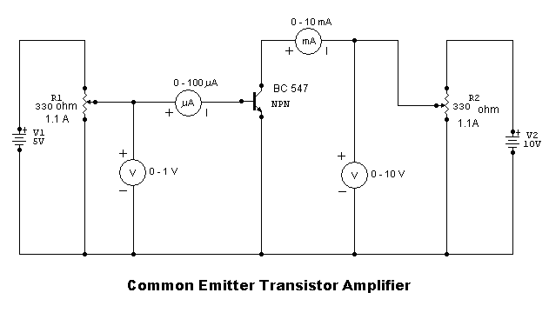

OBSERVATION TABLE
Input characteristics
VCE =0V |  | VCE = 3V |  | VCE =5V
VBE (V) | IB (uA) | VBE (V) | IB (uA) | VBE (V) | IB (uA)
0.1 | 0 | 0.1 | 0 | 0.1 | 0
0.2 | 0 | 0.2 | 0 | 0.2 | 0
0.3 | 0 | 0.3 | 0 | 0.3 | 0
0.4 | 0 | 0.4 | 0 | 0.4 | 0
0.5 | 4 | 0.5 | 0 | 0.5 | 0
0.6 | 24 | 0.6 | 4 | 0.6 | 3
0.7 | 54 | 0.7 | 22 | 0.7 | 20
0.8 | 90 | 0.8 | 54 | 0.8 | 52
 |  | 0.9 | 90 | 0.9 | 90

Output characteristics
IB =10µA |  | IB =20µA |  | IB =30µA
VCE (V) | IC=(mA) | VCE (V) | Ic=(mA) | VCE (V) | Ic=(mA)
1 | 2.7 | 1 | 5.5 | 1 | 7.6
2 | 2.7 | 2 | 5.6 | 2 | 7.6
3 | 2.7 | 3 | 5.7 | 3 | 7.6
4 | 2.7 | 4 | 5.8 | 4 | 7.7
5 | 2.8 | 5 | 6.0 | 5 | 7.7
6 | 2.8 | 6 | 6.1 | 6 | 7.7
7 | 2.8 | 7 | 6.2 | 7 | 7.7
8 | 2.8 | 8 | 6.2 | 8 | 7.7
9 | 2.8 | 9 | 6.4 | 9 | 7.7

CALCULATION
1) Dynamic output impedance (ro) = ∆Vce / ∆ Ic keeping IB constant
(5-4)/(2.8-2.7) *10^-3 = 10kΩ
2) Dynamic input impedance (ri) hie = ∆ Vbe /∆ IB keeping VCE constant
(0.7-0.6)/(17-3) *10^-6 =7.14 kΩ
3) Current gain(α) h _{fe}= ∆Ic/∆ IE =(6.4-2.9)*10^-3 / (20-10)*10^-6 =350
4) reverse voltage gain h _{re} = 1/(∆ Vce/ ∆ Vbe)= 1/(5-3 / 0.8-0.7 ) = 0.05
5) output admittance =10^-4 s

RESULTS:
Input and output characteristics of C E configuration are plotted.

1) Dynamic input impedance hie = 17.14 k ohm
2) Dynamic output impedance =10 kΩ
3) Current gain h _{fe} = 350
4) reverse Voltage gain h _{re}= 0.05
5) output admittance=10^-4 S

INFERENCE:

- In common emitter configuration the emitter terminal is common to input and output
- The base current acts as input current and collector current acts as output.
- Input impedance is moderate because base current is order of micro amperes and small change in Vbe produces large change in Ib.
- Output impedance is high but lower than in C B since output curve is not exactly parallel to x axis.

